Data analysis

Motivated by the art scenes in Edinburgh, we chose to focus on exploring the public art data sets of Edinburgh and aims to probes and present some visualizations tailored to our findings and insights. Following our chosen topic, we used python to analyzed the public art data from 3 different aspects, including the development of public art over time, geographical distribution and material usage.

It is showed that, in general, there are 152 public art in Edinburgh in total. The earliest one existed in 1685, called ‘Charles II’, which has a history of more than 300 years. Four public art existed in 2020, including ‘Scotland, together, persevere, NHS’,’ Free Speech’, ‘Unity’ and ‘The Protest’. After that, we analyzed more details about the development of public art in Edinburgh over time. It is illustrated by the bar chart, the 20th century saw the most public art established in Edinburgh, accounting for 40.1%. While public art before the 19th century made up only 1.3% of the total. From 18th century, the number of newly established public arts increased during each century. Although it is only the first decade of the 21st century, 43 new public art projects have been created, accounting for 28.3 percent of total.

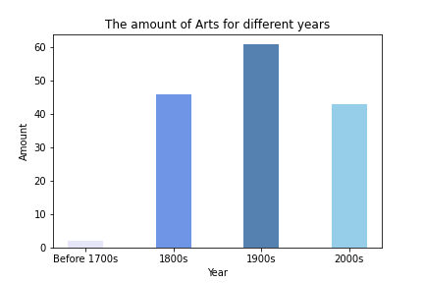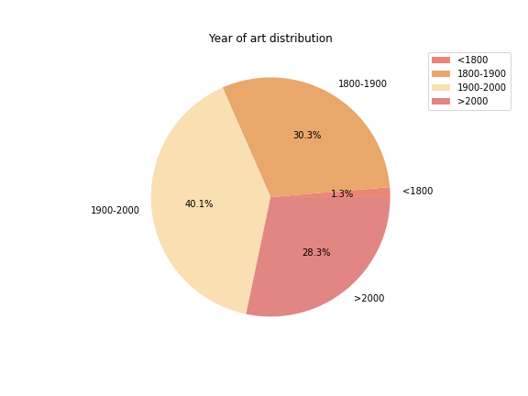

In addition, our group try to explore how is the public art in Edinburgh distributed spatially. As it shown in the geographical distribution heat map and the location scatter plot, public art is not evenly distributed in Edinburgh and there are some areas where the density of art is huge and some areas where the density is scarse. To be more specific, it could be seen that public art is mainly concentrated in the city center area in Edinburgh.

Finally, for the type of the public art, the data set offers us detail information about the public art type. Using Wordcloud in python, we find that Edinburgh has a wide variety of public art, mainly including sculpture, statue, stone and monument.

